Seed Clustering Study
How much structure can you find without the labels using Clustering?

Mohammad Kian Zohourian
September 2026
ERASMUS+ LEAP

Table of Contents
- Abstract |  |  | 3
- Introduction |  |  | 3
- Dataset |  |  | 4
- Methodology |  |  | 5
- Data Preparation |  |  | 5
- PCA |  |  | 5
- K-Means |  |  | 6
- Findings – Unsupervised Analysis |  |  | 6
- Validation |  |  | 6
- Cross-tabulation |  |  | 7
- Purity Score |  |  | 7
- Colored PCS plot |  |  | 8
- Discussion |  |  | 9
- Ethical Considerations / Limitations |  |  | 10
- Conclusion |  |  | 11
- Reproducibility |  |  | 12
- References |  |  | 13
- Abstract

In this project we aim to test how well we can group unlabeled products in their relevant category using clustering as our basis. We make use of PCA and K-Means in python to try to regroup different entries in a dataset of 210 seeds, containing 7 different measurements of each.
After reducing the features to 2 using Principal components and capturing 88% of the variance of the dataset, through different tests such as the inertia elbow method and silhouette score, we have come to the conclusion of using 3 clusters and 3 varieties of seeds, which turned out to be true in our target feature. Our clustering managed to get a purity score of 92%.
It must be taken into consideration that the clustering made in this project is purely based on numeric measurements and statistical/ mathematical calculations and they do NOT represent biological factors.

- Introduction
An agricultural co-op receives deliveries of mixed wheat grain and suspects it contains several distinct varieties, but the deliveries arrive unlabeled. Before investing in a labelling or sorting process, the co-op wants to know how many varieties are plausibly present and how cleanly they separate on a few simple measurements. Our task is to find that structure using clustering alone, then judge how much of it is real.
By being able to find the number of varieties in the deliveries, we can facilitate the future steps of the process, such as containment and sorting.
Clustering can assist us with estimating or foreseeing the number of varieties we have in the deliveries, and for that we make use of the seed’s measurements and K-Means method.
The central question we are trying to answer is: How much of the real class structure can clustering recover without using the labels?

- Dataset
The dataset used for this study is called Seeds from 2012, and the courtesy of: Magorzata Charytanowicz, Jerzy Niewczas, Piotr Kulczycki, Piotr Kowalski, and Szymon Lukasik.
The examined group comprised kernels belonging to three different varieties of wheat: Kama, Rosa and Canadian, 70 elements each, randomly selected for the experiment. High-quality visualization of the internal kernel structure was detected using a soft X-ray technique. It is non-destructive and considerably cheaper than other more sophisticated imaging techniques like scanning microscopy or laser technology. The images were recorded on 13x18 cm X-ray KODAK plates. Studies were conducted using combine harvested wheat grain originating from experimental fields, explored at the Institute of Agrophysics of the Polish Academy of Sciences in Lublin.
The data can be found on: https://doi.org/10.24432/C5H30K
Here is a list of the features:
[1. area A, 2. perimeter P, 3. compactness C = 4*pi*A/P^2, 4. length of kernel, 5. width of kernel, 6. asymmetry coefficient 7. length of kernel groove.]
All these parameters were real-valued continuous.

- Methodology

  - Data prep
All features in the data are numeric measurements. So not much preprocessing is required. The only preprocessing done in this study was to scale the features so they would be suitable for K-Mean and clustering

  - PCA
For the sake of simpler visualization of the data, we have reduced the features into two using principal Component Analysis and illustrated a 2D scatter plot. Our new features seem to capture 88% of the variance of the data

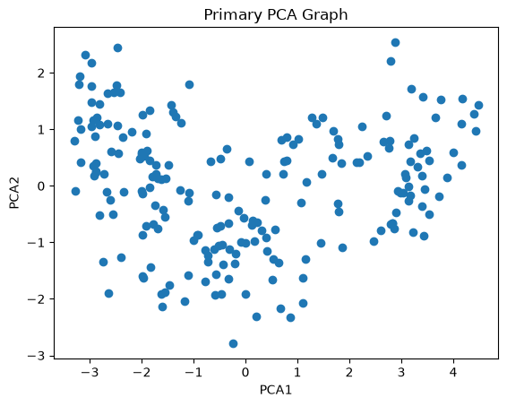

- A scatter plot of data points in 2D of PCA features

4.3. K-means
Based on our first scatter plot from the newly crafted features, we had the hypothesis of 3 to 4 cluster points existing. So, we have calculated the inertia and silhouette scores for our K-mean for from 2 to 7 centers and made our decision based on their results
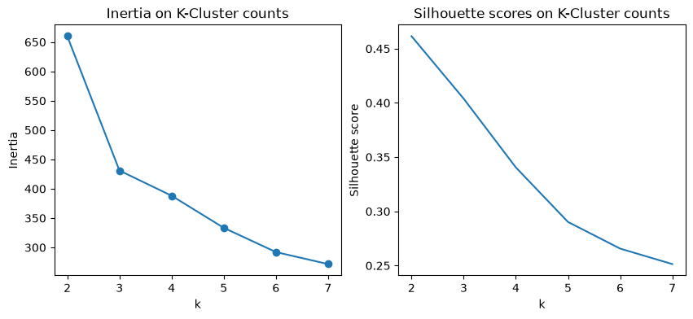
- Elbow method and Silhouette scores

- Findings – Unsupervised Learning
After calculating the silhouette score and inertia for various amounts of k (clusters) we have come to the decision of choosing 3 as our k since the elbow method in the inertia graph supports our idea. The highest silhouette score might belong to 2 clusters, but we would probably lose a lot of variances. The first scatter plot does indeed suggest having more than 2 clusters and 3 has a valid silhouette score.
We have now 3 cluster points with the following coordinates:
 | area | perimeter | compactness | kernel_length | kernel_width | asymmetry | groove_length
0 | 18.37971 | 16.15614 | 0.88362 | 6.1637 | 3.681986 | 3.606286 | 6.028586
1 | 11.81727 | 13.23879 | 0.846567 | 5.236 | 2.836152 | 4.899379 | 5.122
2 | 14.20892 | 14.22649 | 0.88085 | 5.472392 | 3.234892 | 2.719503 | 5.076243

- Validation
After comparing the real number of varieties to our findings and conclusions, we understand that our result has been correct and there are actually three varieties available

  - Cross-tabulate

This table shows the cluster labels (labels) against the true varieties. (Columns)
We have used a cross-tabulate to cross check our labels to the real label of each seed.

 | True Varieties
Cluster Label |  | 1 | 2 | 3
Cluster Label | 0 | 3 | 67 | 0
Cluster Label | 1 | 3 | 0 | 63
Cluster Label | 2 | 64 | 3 | 7

Based on this table, we can see that the model has done well on dividing the seeds cleanly with a few seeds spread into the other groups.

  - Purity score

Thanks to the information in the cross tabulate we can calculate the purity score of our clustering by summing the max values of each column in the table and dividing it by the sum of all values, showing us how pure each of our clusters is. In this case our purity score is 92.38% which shows a good percentage of purity

  - Colored PCA

We have assigned a color to each point by its true variety. K-Means used all seven scaled features, while this plot shows only two PCA dimensions. Points that overlap here may still be separated by information in other dimensions that we cannot see here.

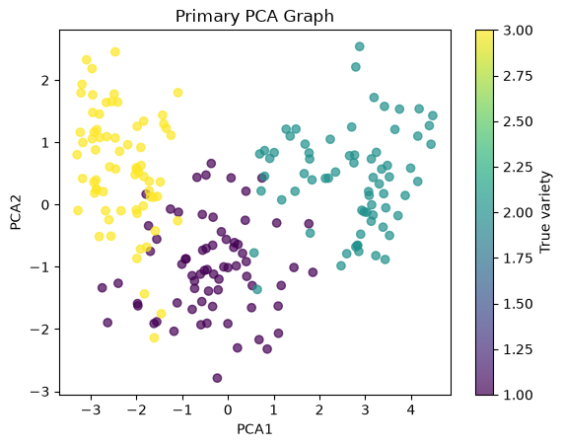

- PCA Scatter plot with colors assigned based on true variety

- Discussion

A purity of 92% indicates that most observations within each cluster belonged to the same true variety. We have seen that Clustering has done a great help recovering much of the underlying class structure among the seeds, but overlapping has been witnessed and the model (as seen in the cross-tabulate) has made mistakes mixing some seeds in the wrong group.
During the process, even if the elbow method and the silhouette scores seemed to be pointing in different direction, by choosing the best middle ground for capturing as much variance without making a cluster of every datapoint.
The clusters seemed to be well separated with a few overlapping (especially in variety 3 and 1); which is also supported by our PCA colored scatter plot.
Please keep in mind that all 7 features were only reduced to 2 using PCA, and this method does not preserve entire variance in the data. So, it is assured that there will be some data and precision lost in its graph

- Ethical considerations / Limitations

Our conclusions are based only on statistical analysis of physical seed measurements. The clusters found by K-Means are not biological facts and they only represent patterns found within this dataset.
The clustering should therefore be used as a decision-support tool, not as a complete replacement for sorting or verification. Relying on the clusters as absolute truth could lead to incorrect classifications and potentially huge losses, especially with larger deliveries.
The choice of k affects the resulting clusters, meaning different choices could produce different conclusions. Likewise, the 92% purity score only shows that our clusters corresponded closely with the known varieties in this dataset; it does not mean the method is 92% certain or universally accurate.
The PCA plots reduce seven measurements to two dimensions, so they should be treated as visual aids rather than a complete representation of the data.
Finally, our study has been done in the simplest manner as it could have been done by using the numerical features given by the data as they are (aside from scaling them) and directly integrating them into our model.

- Conclusion

The clustering analysis found evidence of three distinct groups within the unlabeled seed measurements. K-Means achieved a 92% purity score, while the first two PCA components captured 88% of the dataset's variance. This shows that clustering was able to recover a substantial portion of the structure corresponding to the true varieties without referring to their labels.
However, the results are not perfect and should be treated as statistical evidence rather than definitive identification. The analysis demonstrates that clustering can be a useful aid in distinguishing mixed seed deliveries, but further verification would be needed before using it as a standalone sorting method for higher confidence and to avoid unnecessary loss.

- Reproducibility

The libraries and tools used in this study are listed below:

Python == 3.13.6
ipykernel==7.3.0
ipython==9.17.1
ipython_pygments_lexers==1.1.1
jupyter_client==8.10.0
jupyter_core==5.9.1
matplotlib==3.11.2
matplotlib-inline==0.2.2
numpy==2.5.3
packaging==26.3
pandas==3.0.5
scikit-learn==1.9.1
scipy==1.18.1
seaborn==0.13.2

The script was compiled in a Jupyter notebook using VS code.

- References

- UCI Machine Learning Repository - Seeds Dataset
https://archive.ics.uci.edu/dataset/236/seed

- scikit-learn - K-Means / clustering documentation:
https://scikit-learn.org/1.2/modules/generated/sklearn.metrics.silhouette_score.html

- scikit-learn - Silhouette analysis
https://scikit-learn.org/stable/auto_examples/cluster/plot_kmeans_silhouette_analysis

- LEAP ERASMUS + - Machine Learning
https://elearning.auth.gr/course/view.php?id=20807 (Might be deactivated due to the module being over)

- Kaggle – Feature Engineering
https://www.kaggle.com/learn/feature-engineering

